2024 Knox Outreach Initiative
Report to the DHUC on-line Bulletin from Sharyn Devine, Coordinator

Laura Tarver, daughter of Glenn Tarver and Sharyn Devine, on behalf of Don Heights Unitarian Congregation, delivered the following to the 202 Markham Road Knox Outreach location on the morning of Sunday January 28th, 2024:
- 50 Ham Sandwiches
- 80 egg salad, potato, chick peavegan and other meat free sandwiches
- Sliced turkey, Provolone cheese, Cheddar cheese
- 100 juice boxes and 80 water bottles
- Several large trays of salads including carrot, pasts chick pea, potato and bean salad
- Apples, Clementines and grape clusters
- Snack items: 150 plus granola bars and many, many individually wrapped treats.
- 200 snowman gingerbread cookies from Laura Tarver’s food classes
- 120 coupons for Tim’s at $10 each from Irene Ierullo and Gerry Small
- 140 tubes of toothpaste donated by Dr. Denis
- BBQ sauces and sugar packets needed by the centre
- Metro groceries donated $175 in coupons towards some of the food items above and many bakery items.
- Michel’s bakery donated bread, buns, pizza and desserts.
On the Sunday, people who are cold and hungry come in from outside to rest, get warm and enjoy the food we have prepared for them.

All of the above foods were prepared/donated by members and friends of Don Heights, including many from our pre-COVID euchre group. A huge thank you all and most particularly to Irene Ierullo..

Previous to the day, Irene took four carloads of clothes, shoes, toiletries –
to Knight’s Inn 22 Metropolitan Road Scarborough

Financial Donations from all sources totaled $2250. Money in excess of expenses will be donated to ACSA (Agincourt Community Services Association).

Sharyn Devine
Knox Outreach Coordinator for
Don Heights Unitarian Congregation

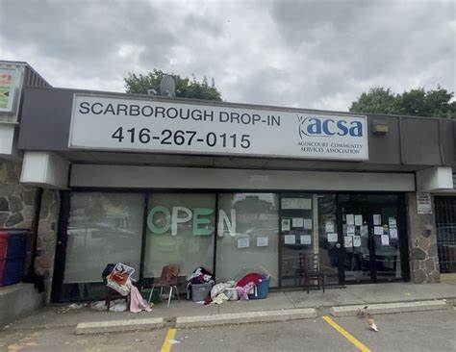  The ACSA south drop in for the Knox Outreach Program | 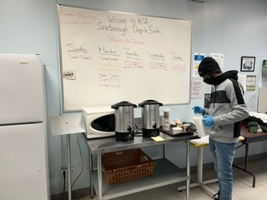  ACSA south - the kitchen | Gingerbread snow people from Laura’s culinary class
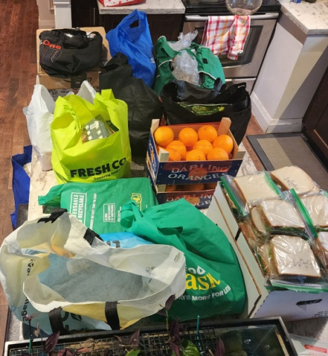Donated food, Laura’s kitchen | 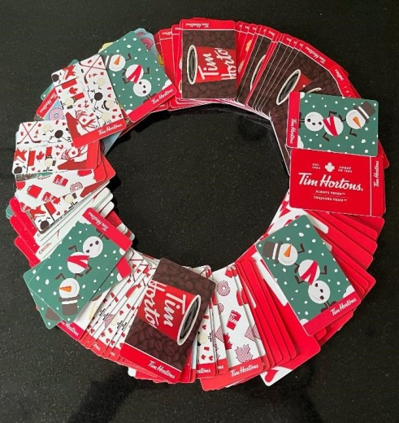Wreath of Tim Horton gift cards | 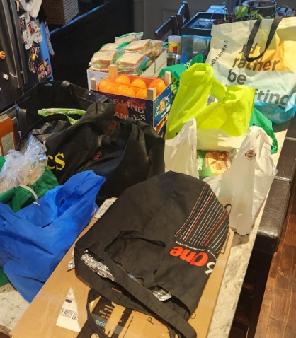 Laura’s kitchen II

